High Frequency 1-30KVA High Performance Online UPS
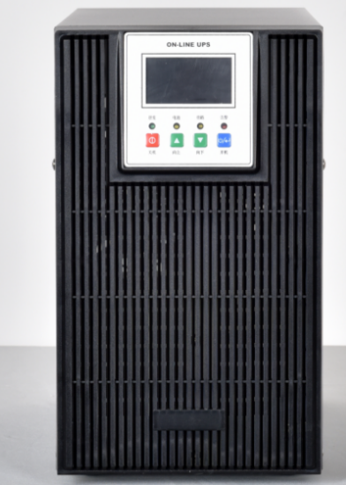
General
The APSW series online series is a product with strong adaptability and flexible configuration. It adopts a double-conversion pure online architecture. It is the most effective architecture design to solve all power problems. It is suitable for power grid problems: power outages and mains voltage over-voltage. High or too low, instant voltage drop or amplitude oscillation, high voltage pulse, voltage fluctuation, surge voltage, harmonic distortion, clutter interference, frequency fluctuation and other conditions can provide good solutions and provide safe and reliable user loads. Ground power supply guarantee; using advanced DSP digital control technology; effectively improving product performance and system reliability, and achieving higher power density and integrated miniaturization. At the same time, in order to fully meet the personalized needs of users, the high-frequency online series 1K-20K provides a very rich set of scalable functions that users can flexibly configure according to their needs.
Application
Servers, storage, network equipment, communication equipment, automation equipment, precision instruments, OFFICE office terminals, monitoring, security systems, and important home appliances. Telecommunications, finance, government, medical, education, manufacturing, postal/logistics, transportation, commerce/retail.
Features
1. Ultra-compact and high power density design, the overall volume is 20% to 70% smaller than similar products.
2. Double conversion online design ensures high reliability of power supply.
3. Ultra-wide input voltage/frequency range, adaptable to harsh power grid environment.
4. Large-screen LCD display makes settings more direct and convenient to obtain working status.
5. Within the input voltage range of 120 ~ 288V, the output is not derated, which greatly reduces the probability of battery transfer and increases battery life.
6. Super overload capacity: Under the mains power rating, 130% can be used for 5 minutes and 150% can be used for 10 seconds, meeting the customer's sudden load requirements.
7.1-8A long-term charging capacity, the charging capacity can be set to meet the rapid recharge of long-delay batteries and improve battery life.
- Excellent environmental protection and energy-saving characteristics, the efficiency is 3-4 percentage points higher than similar products and can be as high as 91%.

Technical Specifications.
Model |  | APSW-110001 |  | APSW-110002 |  | APSW-110003 |  | APSW-110006 | APSW-110010 |  | APSW-310010 | APSW-310015 | APSW-310020 | APSW-310030
Power Rating |  | 1KVA/800W |  | 2KVA/1.6KW |  | 3KVA/2.4KW |  | 6KVA/4.8KW | 10KVA/8KW |  | 10KVA/8KW | 15KVA/12KW | 20KVA/16KW | 30KVA/24KW
Phase |  | Single Phase Input, Single Phase Output |  |  |  |  |  |  |  |  | Three Phase Input, Single Phase Output
Input
Voltage Range |  | 115-276VAC |  |  |  |  |  |  |  |  | 210-487VAC
Frequency Range |  | 47~53Hz or 57~63Hz
Factor |  | 0.99@ Rated voltage (100% load)
Output
Output Voltage |  | 208/220/230VAC/240V±1%
Frequency Range |  | Synchronization with input (mains mode)50Hz±01Hz or 60Hz±01Hz (battery mode)
Power Factor |  | 0.8
Transfer Time |  | 0ms
Output Waveform |  | pure sine wave
Over-load Ability |  | In the mains state, load <110%,30 minutes,110%, load <130%, 5 minutes,130%, load <10s
Battery
Long-run Machine | DC Volt | 36VDC |  |  | 72VDC |  | 96VDC | 192VDC |  |  | 16pcs（16-20pcs optional）
Long-run Machine | Size | 145*282*220 |  |  | 145*397*220 |  | 145*397*220 | 190*415*318 |  | 190*415*318 | 190*442*318 | 250*592*576 |  | 250*815*826
Environment
Humidity |  | 0-90% (no condensation)
Noise |  | Less Than 45dB@ 1 Meter
Control Management
Smart RS-232 Optional USB |  |  | Support Windows ®2000/2003XP/Vista/2008,Windows ®/8,Linux.Unix,and MAC
SNMP (Optional) |  |  | Power management Supports SNMP management and network management

